**DESIGNING A CERTIFICATE FOR DEBATE COMPETITION USING CANVA**

Project report template:

INTRODUCTION

* 1. Over view:

A certificate is a digital document that confirms its subject is the owner of the public key in the certificate. A certificate is also known as an end-entity or leaf certificate. An end-entity certificate is any certificate that cannot be used to sign other certificates.For instant, TLC/SSL server and client certificates ,email certificates, code signing certificates and qualifies certificates are all end-entity certificates.

* 1. PURPOSE:

Certifications are designated credentials earned by an individual to verify their legitimacy and competence to perform a job. Your certification is typically displayed as a document stating that as a professional, you’ve been trained, educated and are prepared to meet a specific set of criteria for you role. The speech and debate competition award certificate is an official document provided to the participant by higher management as a token of appreciation. These awards motivate non-participants to take part in such activities and get appreciated by other people for their talent and skills. Validation of knowledge. Increased marketability. Increased earning power. Enhanced academic performance.

2. PROBLEM DEFINITION & DESIGNING THINKING:

2.1 Empathy Map:

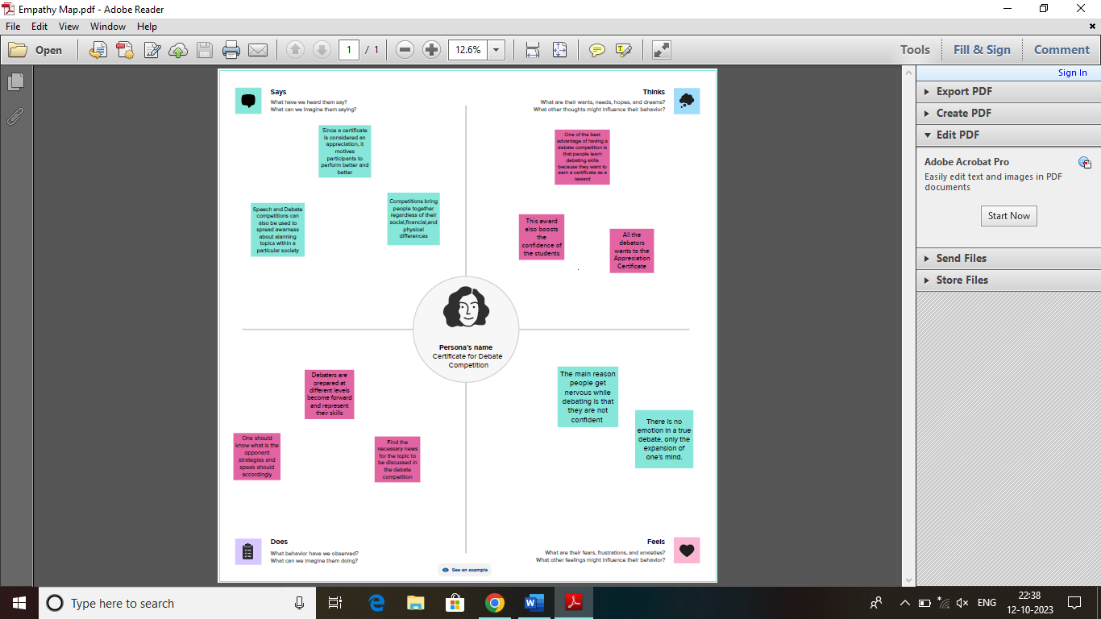

* 1. Ideation & Brainstorming:

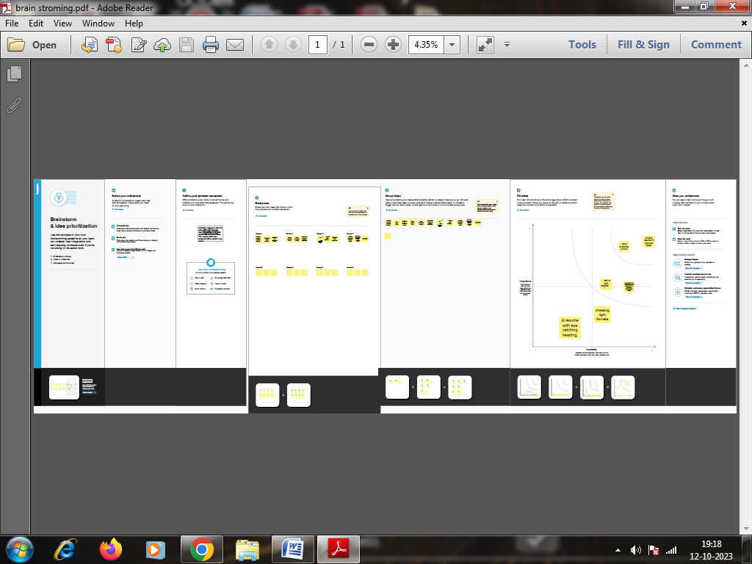

1. RESULT:

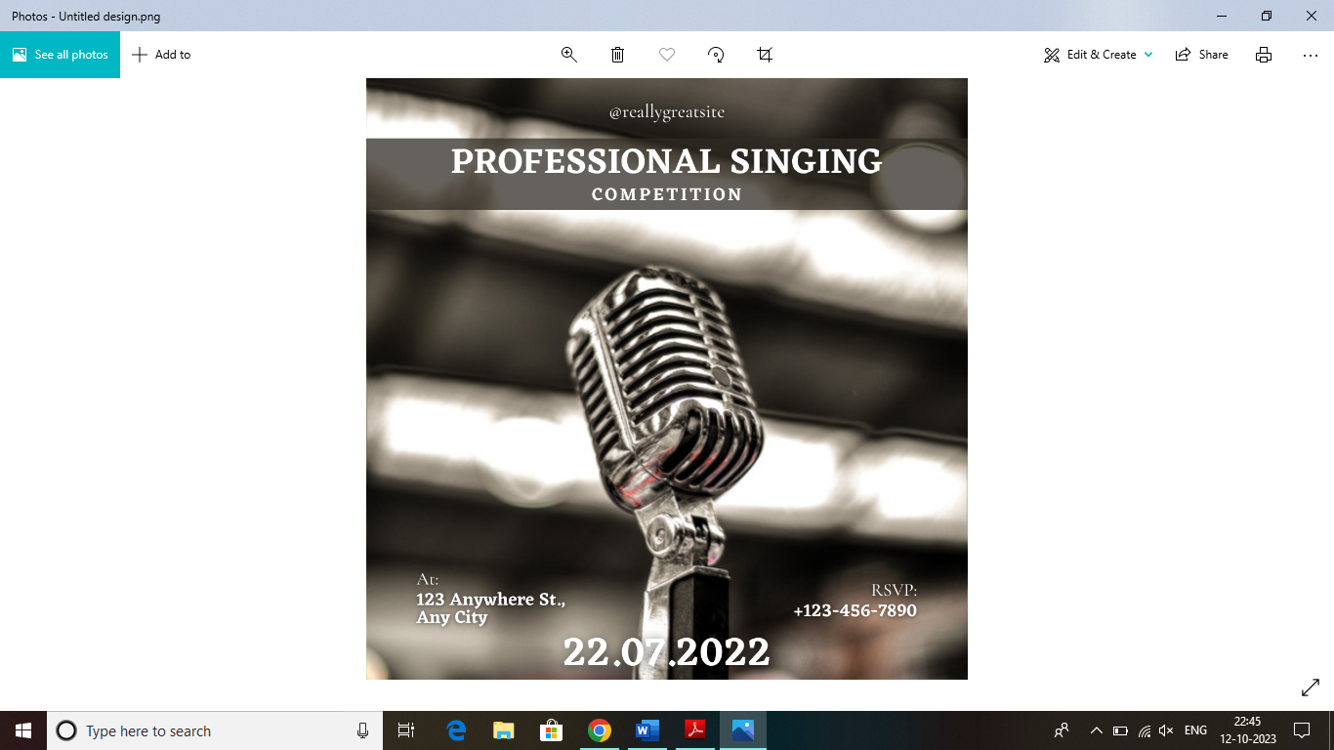

1. ADVANTAGES AND DISADVANTAGES:

* The main benefits of competition policies include increased product quality, more options, low prices and innovation.
* Certification courses offer several advantages for individuals looking to advance their careers or acquire new skills.
* The main disadvantage of competition policies include shrinking businesses market share and surplus of production.
* Certificate rates may be lower than the rate of inflation. This means that your money may loss its purchasing power over time if interest gains of outdone by inflation rates.

1. APPLICATION:

A competition in which teams of people, often students, discuss a subject and the team that is judged to make the best arguments wins.

1. CONCLUSION:.

A document which certifies that someone has completed a course or other kind of programme.